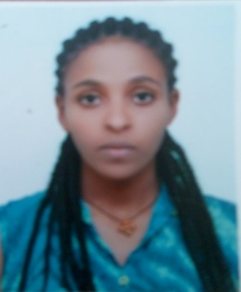

Personal information
First name/ Surname:  Date of birth:  Educational  Background: | Meseret adane ayal  April 19,1983 E.C  Place of Birth Region 3 (Amhara) Bahir Dar  Level-III in TVET Dress Making and Tailor from Bahir Dar Polytechnic College - on July, 2003 E.C  B.Sc Degree in Fashion Design student in Bahir Dar University – EiTEX, from September, 2007 E.C to date
Telephone(s) : | +251-0942831079
Fax(es) : | +251-582-26-62-46 or +251-582-26-44-63
E-mail(s) :
Nationality : | Ethiopian
Sex : | Female
Marital Status : | Married
Appointments: | September 01,2006 E.C- September 01,2007 E.C -Technical Assistance –I
 | September 01,2007 E.C – to date -Technical Assistance –II
Work experience: | Teaching and Administrative assignments  01-10-2003 – 09-04-2004 E.C Operator on Glove Production in Bahir Dar Tannery  10-04-2004 – 30-12-2005 E.C Teaching on motta TVET College in Garment  department  September 01,2006 E.C- September 01,2007 E.C -Technical Assistance –I  September 01,2007 E.C – to date -Technical Assistance –II  Now I have Four year and 4 months Teaching experience in Bahir Dar  University, EiTEX in Apparel Production RIC Director  Committee Work  2nd -5th EiTEX CAT-International conference actively participate on different  committee works and Technical work involvement
Certifications and
awards

Mother tongue(s):  Other language(s): | Amharic  English
Self-assessment : |  | UNDERSTANDING |  | SPEAKING |  | WRITING
 |  | Listening | Reading | Spoken interaction | Spoken production
Amharic: |  | Proficient user | Proficient user | Proficient user | Proficient user | Proficient user
English: |  | Good | Good | Good | Good | Proficient user
Social skills and competences:  Additional information: | In terms of interpersonal communication, I am responsive to my colleagues and eager to help whenever possible. Have well team work, able to consider and analyze different opinions, and take the lead when necessary. I am good at persuading others by creating relationships based on mutual trust and understanding.  Addisu Ferede (Assistance Professor)  Scientific Director of EiTEX,  Bahir Dar university,  Bahir Dar, Ethiopia.  Office Tel: +251-582-20-27-72  Fax : +251-582-26-62-46  Email: Addisufered@yahoo.com  Mr. Amare Abuhay  Apparel Production Research and Innovation Centre Director (AP-RIC)  Bahir Dar University-EiTEX  Bahir Dar, Ethiopia.  Mob. Phone- +251-918-285-676  Fax : +251-582-26-62-46  Email: amare2000et@gmail.com

