PERSONAL INFORMATION
Kura Alemayehu Beyene

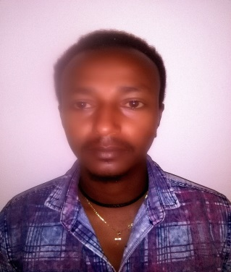

WORK EXPERIENCE

Kebele 16, Bahirdar, Ethiopia
+251-910 30 70 04
kuraalemayehu@gmail.com
RiC: - Textile production
LRI: - Textile testing and quality control(TTQC)
Sex Male |Date of birth16/08/1991 |Nationality Ethiopian

July, 2016-- Present | Assistant Lecturer at Bahir-Dar University, Ethiopian Institute of Textile and Fashion Technology, Bahir Dar, Ethiopia.
EDUCATION AND TRAINING

April, 2011- June, 2016

Bachelor of science in Textile Engineering, Bahir-Dar University, Ethiopian Institute of Textile and Fashion Technology(EiTEX), Bahir Dar, Ethiopia.

Higher Development program (HDP)
October, 2016- June, 2017

Secondary and Preparatory Education at Ambo Senior and Secondary School, Ambo, Ethiopia.
October 2007 –June,2010

October, 1998- June, 2007
Elementary and Junior Education at Ambo Addisketema Elementary School,
Ambo, Ethiopia

PERSONAL SKILLS

Communication
- English:- Good in all skills
- Afaan Oromo:- Excellent in all skills
- Amharic:- Excellent in all skills

Digital competence SELF-ASSESSMENT

Information processing | Communication | Content creation | Safety | Problem solving
Proficient user | Independent user | Independent user | Independent user | Basic User

Reference
Name | Contact Addresses
 | Mobile No. | e-mail address
As.Prof. Addisu Ferede | +251-930351924 | addisiotex@gmail.com
As. Prof. Adane Haile | +251-936343489 | adane777@yahoomail.com

