PERSONAL INFORMATION
Feteya Hayredin Edress

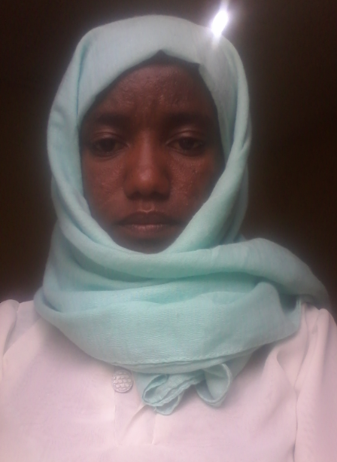

WORK EXPERIENCE

Kebele 8, Bahirdar, Ethiopia
+251-920 55 70 41
hayre2008@gmail.com
Sex Female |Date of birth27/03/1986 E.C |Nationality Ethiopian
July, 2008 E.C-- Present | Assistant Lecturer at Bahir-Dar University, Ethiopian Institute of Textile and Fashion Technology, Bahir Dar, Ethiopia.
EDUCATION AND TRAINING

April, 2004- June, 2008 E.C

Bachelor of science in Textile Engineering, Bahir-Dar University, Ethiopian Institute of Textile and Fashion Technology(EiTEX), Bahir Dar, Ethiopia.

Preparatory Education at Medhanialem Peeparatory School, Adis abeba, Ethiopia
September 2002 –June,2003E.C

Secondary Education at Miraf Secondary School, Addis abeba, Ethiopia
September 2000 –June,2001E.C

September, 1998- June, 1999E.C
Elementary Education at Medhanialem Elementary School, , Addis abeba
, Ethiopia

PERSONAL SKILLS

Communication
- English:- Good in all skills
- Siltgna:- Excellent in all skills
- Amharic:- Excellent in all skills

Digital competence SELF-ASSESSMENT

Information processing | Communication | Content creation | Safety | Problem solving
Proficient user | Independent user | Independent user | Independent user | Basic User

Reference
Name | Contact Addresses
 | Mobile No. | e-mail address
As.Prof. Addisu Ferede | +251-930351924 | addisiotex@gmail.com
As. Prof. Adane Haile | +251-936343489 | adane777@yahoomail.com

