Personal information

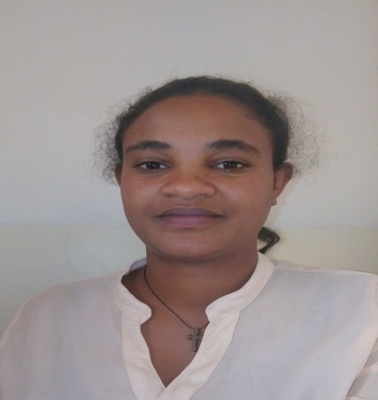

First name/ Surname:  Date of birth:  Educational  Background: | Yewebdar getachew alemu  August 24.12.1984 E.C  Place of Birth Region 3 (Amhara) Bahir Dar  Level-III in TVET Dress Making and Tailor from Bahir Dar Polytechnic College - on July, 2003 E.C  Level Iv apparel fashion design and technology supervion from june 19.11.2008-november  01.03.2009 e.c  B.Sc Degree in leather engenringFashion student in Bahir Dar University – EiTEX, from September, 2010 E.C to date
Telephone(s) : | +251-943589696
Fax(es) : | +251-582-26-62-46 or +251-582-26-44-63
E-mail(s) : | yeendexdare5@gmail.com
Nationality : | Ethiopian
Sex : | Fimal
Marital Status : | Married
Appointments: | february01.06,2009 E.C –senior Technical Assistance –I
 | to date
Work experience: | Teaching and Administrative assignments  15.03-2004– 26.02.2007 E.C Operator on Glove Production in Bahir Dar Tannery  27.02.2007 – 30.05.2009 E.C Teaching on bahir dar poly technic College in Garment  department  Now I have tan month Teaching experience in Bahir Dar  University, EiTEX in Apparel Production RIC Director
Mother tongue(s):
Other language(s):
Self-assessment : |  | UNDERSTANDING |  | SPEAKING |  | WRITING
 |  | Listening | Reading | Spoken interaction | Spoken production
Amharic: |  | Proficient user | Proficient user | Proficient user | Proficient user | Proficient user
English: |  | Good | Good | Good | Good | Proficient user
Social skills and competences:  Additional information: | In terms of interpersonal communication, I am responsive to my colleagues and eager to help whenever possible. Have well team work, able to consider and analyze different opinions, and take the lead when necessary. I am good at persuading others by creating relationships based on mutual trust and understanding.  Addisu Ferede (Assistance Professor)  Scientific Director of EiTEX,  Bahir Dar university,  Bahir Dar, Ethiopia.  Office Tel: +251-582-20-27-72  Fax : +251-582-26-62-46  Email: Addisufered@yahoo.com  Mr. Amare Abuhay  Apparel Production Research and Innovation Centre Director (AP-RIC)  Bahir Dar University-EiTEX  Bahir Dar, Ethiopia.  Mob. Phone- +251-918-285-676  Fax : +251-582-26-62-46  Email: amare2000et@gmail.com

