PERSONAL INFORMATION
TIBLET TESFAHUN FELEKE
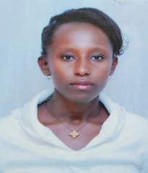
Kebele 11,Bahirdar, Ethiopia
+251-942338582
tiblet22tesfahun@gmail.com
Sex – Female, Date of birth-19/08/1985 Nationality - Ethiopian
WORK EXPERIENCE
21/08/2006 E.C. - Technical assistant I at Bahir-Dar University, EiTEX, Ethiopia.
21/08/2007 E.C. - Technical Assistant II at Bahir-Dar University, Ethiopian Institute of Textile and Fashion Technology, Bahir Dar, Ethiopia.
19/11/2008 - 03/04/2009 E.C. - Bahir Dar polytechnic college in level (IV) apparel fashion design and super vision
01/01/2002 - 2004 E.C. - Education at GIHON Secondary School, Bahir Dar, Ethiopia.
01/01/2001 E.C. - Elementary and Junior Education at TEYMA elementary School, Bahir Dar, Ethiopia.
PERSONAL SKILLS
Good communication skills gained through assisting students in labs and experience as pattern manager during pattern making.
Knowledge of languages
Amharic - Mother Tongue
English - Medium in communication, writing and reading
References
Name | Contact addresses
 | Mobile No. | e-mail address
Amare Abuhay | +251-918285676 | amareabuhay2000@gmail.com
Mulat Alubel | +251-921279440

