CURRICULUM VITAE

Name | Rigat Gebremedhin Gebreyohannis |  | 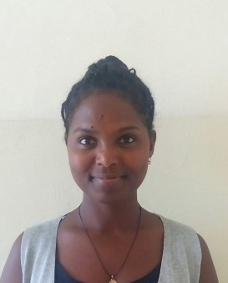
Position | Ass.Lecturer, Textile production  Ethiopian Institute of Textile and Fashion Technology [EiTEX], Bahir dar University
Academic  Background | B.Sc. in Textile Engineering, | Bahir Dar University,  Bahir Dar, Ethiopia |  | 2010-2014
 | MSC.student in textile mfg. | Bahir Dar University |  | 2016-2018
Type of activity | Employer |  |  | Time Period
Training | -R soft ware  -Research methodology  -Kawabata testing machine training
Contact information | Mobile number +251969022908  Email address rigat.gebremedhin@gmail.com

