CURRICULUM VITAE

Name | NEGASI TEKLAY |  | 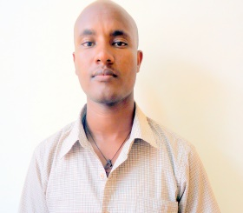
Position | Lecturer, Textile chemistry  Ethiopian Institute of Textile and Fashion Technology [EiTEX], Bahir dar University
Academic  Background | MSc. in Textile chemistry | Bahir Dar University,  Bahir Dar, Ethiopia |  | 2015-2017
 | B.Sc. in Textile Engineering, | Bahir Dar University,  Bahir Dar, Ethiopia |  | 2009-2014
Background | Type of activity | Employer |  | Time Period
Researcher | - Research  - Seminar presented for EiTEX | Bahir Dar University, Bahir Dar, Ethiopia |  | 2013 – 2015 &  2016-2017
Contact information | Mobile number +251912759608  Email address teklaynegasi@gmail.com

