Curriculum vitae (CV) 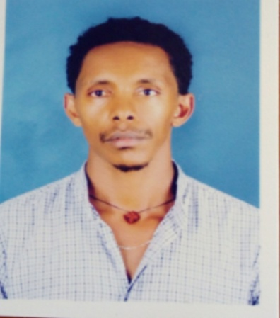
- Personal information
- Name: Frezer Getnet Gebremeskel
Sex: Male
Date of birth: 20-04-1982 E.C
Place of birth: Debark
Nationality: Ethiopian
Address:- Cell phone- 0924870106
0908263170
Tel- +251918215487
Email: frezerg30@yahoo.com
frezerg5@gmail.com
- Educational back ground

No | Level | School Name | Year in E.C | Grade
1 | Elementary | Debark elementary school | 1995-1994 | 1-6
2 | Junior | Debark junior school | 1995-1996 | 7-8
3 | High school | Debark comprehensive school | 1997-1998 | 9-10
4 | Preparatory | Debark preparatory school | 1999-2000 | 11-12
5 | University | Bahir dar university | 2001 - 2005 | _{BSc Degree}

3. Qualification
♦ BSc Degree in Textile Engineering from Bahir dar Ethiopian Institute of Textile and Fashion Technology (EiTEX) On June 29/2013.
4. Experience
- Practical training for 3 months in DH Geda Blanket factory.
- 3 year and 4 months work experience by machine installation, maintenance, product developer, shift leader, supervisor, operator’s trainer and quality and process control manager in Angles’ cotton and Textile Company.
- From November 2016 up to now am working Ethiopian Institute of Textile and Fashion Technology (EiTEX) as assist. Lecturer department of textile production
5. Language skills
Languages | Listening | Speaking | Writing | Reading
Amharic | Excellent | Excellent | Excellent | Excellent
English | Excellent | Excellent | Excellent | Excellent

6. Computer skills
♦ I have good knowledge in Ms-Word, Ms-Excel, Ms-Access, C++, computer application in textile
Engineering (Mat lab) and best knowledge on use of E-mail and internet.
7. Hobbies
- Reading books, magazines and Newspapers
- Watching movies and technological tutorials
- Create new idea
8. Cumulative average GPA 2.65
9. Reference
- Addisu Ferede (assis. prof) Deputy scientific director of Ethiopian institute of textile and garment technology. (+251918708142)
- Mr.TamratTesfaye(MSc), Ethiopian institute of textile and garment technology for Textile Engineering program manager.(+251932207275)

All necessary documents are attached.

