- Personal Information
ENYEW TADESSE ABITEW
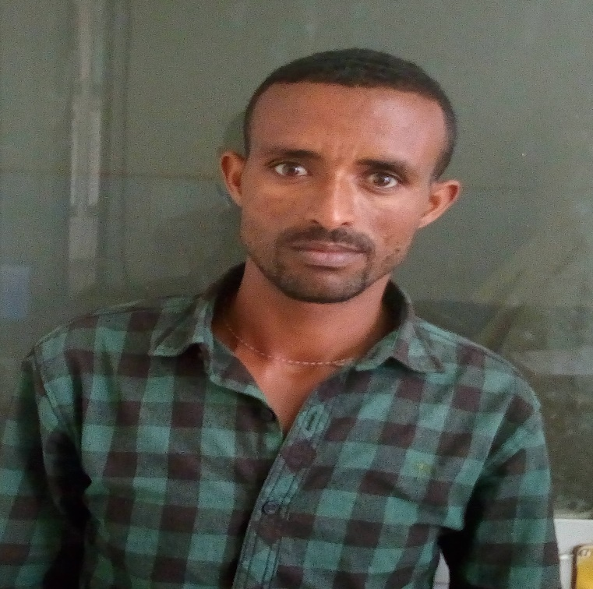

Keble 11, Bahirdar, Ethiopia
+251918511818
ennahusenay@gmail.com
Sex- M
Date of Birth- 1980 G.C
Nationality:-Ethiopian
2 .work experience
- January 2017- technical assistant Bahir-Dar University, EiTEX, Ethiopia
- May 2017 –January 2013 –inspection Quality at Bahirdar Textile Fabrica

3. Education and training
- may 2013/11 - now
- September 2004 –Jun 2003 Weaving oppression textile technology (diploma) at D/ tabor TVET Collage
- September 2002-June 2001 High School: D/Tabor High School in Ethiopia
- September 2000-June 1993 Elementary school: tewedros Elementary in Ethiopia

4. Personal skill Mother tongue(s)- Amharic
Other language (s)
Understanding |  | Writing |  | Speaking
Listening | Reading | Spoken Interaction | Spoken production

English

5. Communication skills
Good communication skills gained through lab assess students and experience as production manager during printing.
Excellent presentation skills gained through experience in lab class
6. Organizational /managerial skills
- Leadership (have been responsible for kaizen team)
- Good organizational skills gained as lab management system
- Good team-leading skills gained kaizen team leader for successive 1.6 year
- Good organizational skills gained as fabric print
7. Digital competence SELF-ASSESSMENT
Information processing | Communication | Content creation | Safety | Problem solving
Proficient user | Independent user | Independent user | Independent user | Basic user

- Good command of office suite (word processor, excel, spreadsheet, presentation software
8. Projects
- Castor oil fibre extraction and characterization
10. Reference
Name | Contact Addresses
 | Mobile No. | e-mail address
As. Prof.Addisu Ferede | +251-930351924 | addisiotex@gmail.com
As. Prof. Adane Haile | +251-936343489 | adane777@yahoomail.com
Biruk fentahun | +251- 942316617 | 2009@gmail.com
Agmasie | + | Agmasie065@gmail.com

11. Certifications
- By Level certificate (in compitant)
- Kaizen certificate at Bahir Dare Textile Factory Share Company

