CURRICULUM VITAE

General Information | Name Daniel Mekonnen Zellele  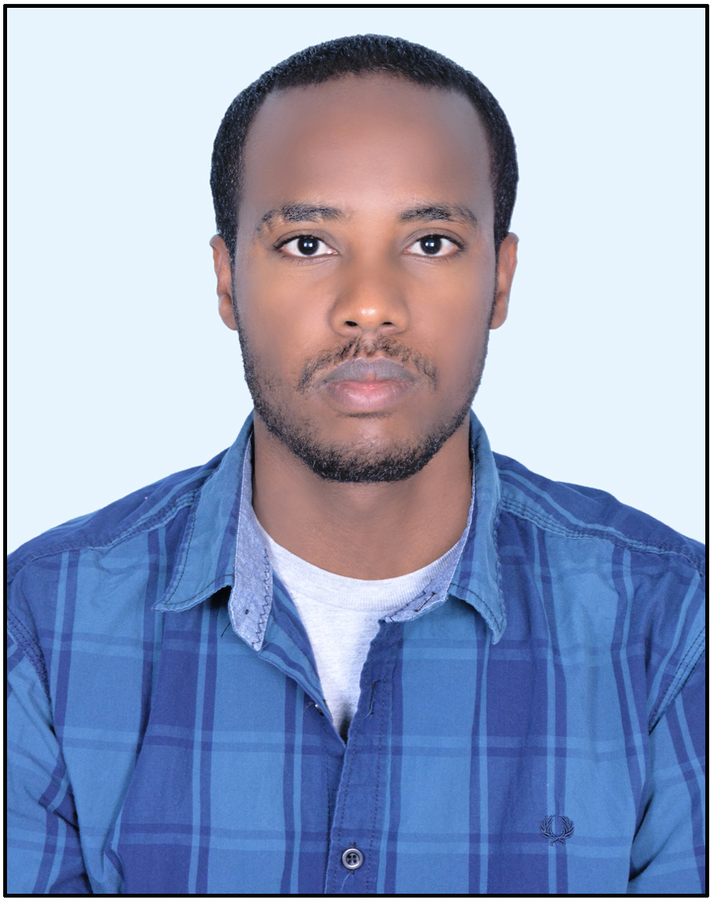  Gender Male  Place of Birth Kobo, North Wollo, ANRS, Ethiopia  Date of Birth 02 January 1987 GC  Nationality Ethiopian  Civil Status Single  Contact Address Mobile – 0913028194  e-mail – danielmekonnenz@gmail.com
Knowledge of Languages | Amharic Mother tongue  English Very good in communication, writing and reading
Current Job Position | Lecturer, Basic Engineering and Sciences RiC  Ethiopian Institute of Textile and Fashion Technology [EiTEX], Bahir Bar University
Academic  Background | BSc in Textile Engineering | Bahir Dar University, Bahir Dar, Ethiopia | 2006-2009
 | MSc in Production Engineering and Management | Faculty of Mechanical and Industrial Engineering, Bahir Dar Institute of Technology, Bahir Dar University, Bahir Dar, Ethiopia | 2015-2017
Experience |  | Employer | Period
- Graduate Trainee  - Laboratory Supervisor  - Dyeing and Printing Section Supervisor  - Shift Leader under Processing Department  - Laboratory Section Head |  | Almeda Textiles PLC, Adwa, Ethiopia | 2009-2011
- Textile Production Engineer |  | SayginDima Textile SC, AA, Ethiopia | 2012 - 2013
- Senior Technical Assistant |  | Ethiopian Institute of Textile and Fashion Technology, Bahir Dar University, Bahir Dar, Ethiopia | Feb. 2016 to June 2017
- Lecturer |  | Ethiopian Institute of Textile and Fashion Technology, Bahir Dar University, Bahir Dar, Ethiopia | Starting from June 2017 to date

