CURRICULUM VITAE

Name | Banchamlak Bemerw kassahun |  | 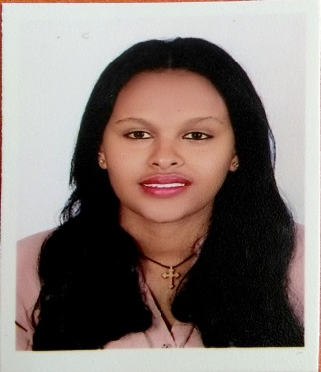
Position | Assistant Lecturer, apparel production RiC  Ethiopian Institute of Textile and Fashion Technology [EiTEX], Bahir Dar University
Academic  Background | BSc. in Leather Engineering  Ethiopian Institute of Textile and Fashion Technology [EiTEX], Bahir Dar University, Bahir Dar, Ethiopia |  |  | 2012-2017
Background | Type of Activity | Employer |  | Time Period
Assistant Lecturer | - Demonstrate lab work in the leather product accessories | Ethiopian Institute of Textile and Fashion Technology [EiTEX], Bahir Dar University, Bahir Dar, Ethiopia |  | Since July 2017
Research Interests | - Improving the leather product manufacturing procedure
Publications | None

