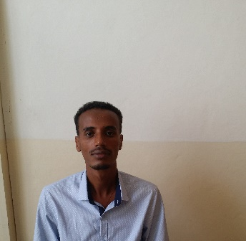
Curriculum Vitae
Abrham Destaw
EiTEX [Ethiopian Institute of Textile and Fashion Technology, Bahir-Dar University, Bahir-Dar, Ethiopia]
Educational Carrier and work Expriance

Curriculum Vitae
Personal and Contact information
First name(s) / Surname(s) |  | Abrham Destaw Mamo
Address |  | Bahir-Dar (Ethiopia)
Mobile |  | +251-921269867
Fax(es) |  | +251- 582-266246
P.O.Box: |  | 1037
E-mail(s) |  | abrhamdestaw25@gmail.com
Nationality |  | Ethiopian
Dates | 18/02/2013 – 27/06/2016
Occupation or Position held | Assistant Lecturer
Dates | 28/06/2016 – up to date
Occupation or Position held | Lecturer
Name and address of employer | Bahir Dar University, EITEX ( Ethiopian Institute of Textile and Fashion Technology), Poly Peda Road, Bahir Dar, Ethiopia
Type of business or Sector | Educational organization ( University)
Dates | 2001-2004 E.C
Title of qualification awarded | BSc. In TVET Garment Engineering
Name and type of organization providing education and training | Bahir Dar University, Engineering Faculty Poly Peda Road, Bahir Dar, Ethiopia
Dates | 01/10/2014– 27/07/2016
Title of qualification awarded | MSc. Fashion Technology
Name and type of organization  providing education and training | Bahir Dar University, EITEX ( Ethiopian Institute of textile and fashion Technology), Poly Peda Road, Bahir Dar, Ethiopia
Training | - SPSS software  - Certified on 3D body scanning software  - R-Software  - Sewing Machine Maintenace
References | 1. Mr. Addisu Ferede <asst. professor>, MTech, Textile Engineering  Director of EITEX, Bahir-Dar University  E-mail: addisiotex@gmail.com  Phone: +251-918-708142

