- PERSONAL INFORMATION

- Name---------------Abrham Belayneh Mengistu
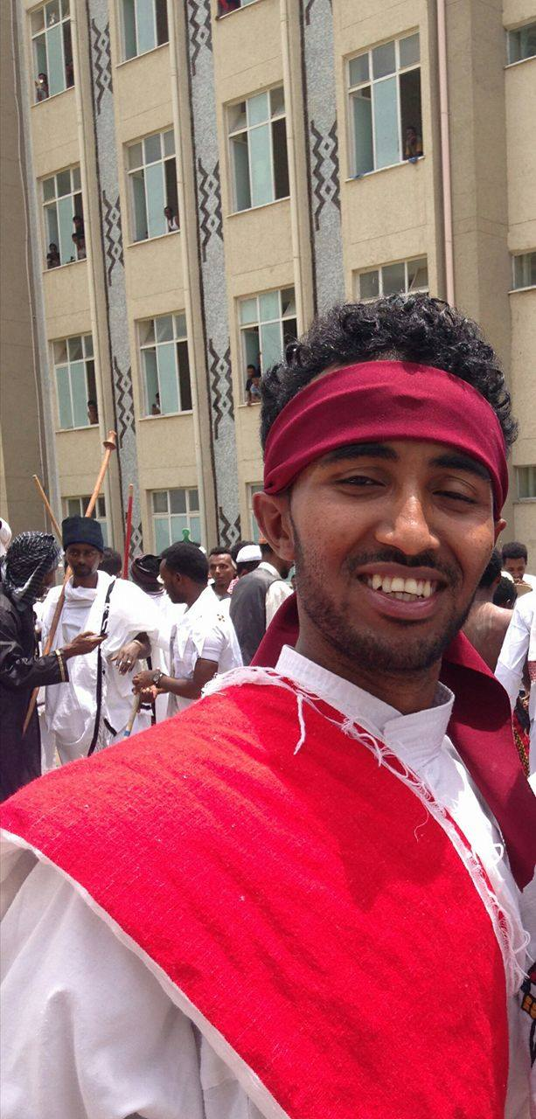
- Sex-------------------Male
- Date of Birth-------December 25, 1993
- Place of Birth-------Gondar, Ethiopia
- Nationality----------Ethiopian
- Address--------------Bahir Dar, Ethiopia
- Mobile phone------- (+251)-918-543-944
- Email---------------- abrshiye@gmail.com

- EDUCATIONAL BACK GROUND

Title: - Assistant lecture
LRI: - Woven and non woven
RIC: - Textile production
Bahir-Dar University

3. MAJOR QUALIFICATION
- B.S.c. Degree in Textile Engineering

