CURRICULUM VITAE
- PERSONAL INFORMATION

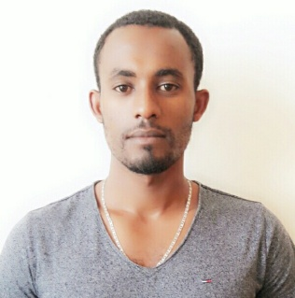
Name: Abenezer Fikre Hailemariam
Date of birth: April 21, 1990
Place of birth: Jimma, Oromia Region, West Ethiopia
Marital status: Single
Nationality: Ethiopian
Address: Tel. (Mobile) - + 251-920-247-636
E-mail Adress: Abinirfikre@gmail.Com
Current Address: Bahir Dar
2. EDUCATON BACK GROUND
YEAR BACK GROUND INSTITUTE PLACE
1998-2005 Elementary Mendera Elementary School Jimma
2006-2007 Secondary Jireen Secondary School Jimma
2008-2009 Preparatory Jimma Preparatory School Jimma
2010-2015 University Bahir Dar University Bahir Dar

3. EDUCATIONAL QUALIFICATION
Bachelor of Science (BSC) in textile engineering from Bahir Dar University, Ethiopian institute of textile and fashion technology.
4. WORK EXPERIENCE
I have been working in Kanoria Africa textile PLC (Denim factory). I have been working in weaving preparatory department as supervisor since 18-jul-2015 up-to 10-feb-2017.
5. Position
Assistance lecturer: At Ethiopian institute of textile and fashion technology, Bahir Dar University.
6. HOBBIES
Reading, playing keyboard, piano and foot ball.
7. LANGUAGE SKILL
Good Command of Written and Spoken English, Amharic and Afaan Oromo.
8. SPECIAL SKILL
Basic computer skill: Microsoft word
9. REFERENCE
Will be presented as request.

