1.Personal Information
- Keble08,Bahirdar, Ethiopia
+251911741764
adanechmeku@gmail.com
Sex- F
Date of Birth- 1992G.C/1984E.C
Nationality:-Ethiopian

ADANECH MEKURIAW
KEMIE
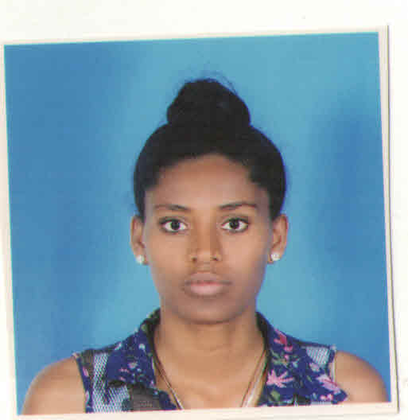
2 .work experience
- August 29/2004 E.c- technical assistant at Bahir-Dar University, EiTEX, Ethiopia
3.Education and training
- September 2017 Present- Studying Textile Engineering at EITEX, Bahir Dar University
- September 2010 –August 2011weaving operation (level 3) at Bahir Dar TVET Collage
- September 2008-June 2009 High School: Dejen gojam ber Secondary School in Ethiopia
- September 1999-June 2007 Elementary school: Yetnora primary school in Ethiopia
4. Language skill
Language | Speaking | Reading | Writing
English | Good | Excellent | Excellent
Amharic | Excellent | Excellent | Excellent

5. Communication skills
Good communication skills gained through lab assess students and experience as production manager during printing.
Excellent presentation skills gained through experience in lab class
6. Organizational /managerial skills
- Leadership(have been responsible for kaizen team)
- Good organizational skills gained as lab management system
- Good team-leading skills gained kaizen team leader for successive 1.6 year
- Good organizational skills gained as fabric print
7. Digital competence SELF-ASSESSMENT
Information processing | Communication | Content creation | Safety | Problem solving
Proficient user | Independent user | Independent user | Independent user | Basic user

10. Reference
Name | Contact Addresses
 | Mobile No. | e-mail address
As. Prof.Addisu Ferede | +251-930351924 | addisiotex@gmail.com
Mr.Dagu Melak | +251-936343489 | degmelkum@gmail.com
11. Certifications
- Certificate of participation as organizing committee in the 3rd International conference on Cotton, Textile and Apparel Value Chain in Africa, EiTEX, BahirDar University, 2014. G.C

